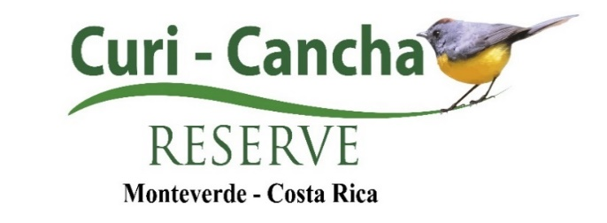
Aránea S.A.
Corporate Identification #3-101-321913

Mutual Responsibility Agreement
As a user, I hereby affirm and acknowledge that my participation in the tours (which are regulated and defined under current legislation, on Adventure Tourism activities, Executive Decree No. 39703-S-TUR, signed by the President of the Republic and published in the official journal La Gaceta on June 6, 2016, in which Adventure Tourism is understood as guided tourist activities that take place in a natural environment, on land, water or air, to explore and experiment, assuming generally the existence of the risk factor and a certain degree of dexterity or physical effort associated with personal challenges) developed by the company Aránea S.A., corporate ID number 3-101-321913 (also known as, Curi-Cancha Reserve) and hereinafter referred to as RCC, is done at my own risk. I further acknowledge that I have been informed that the hours for the use of the Curi-Cancha Reserve facilities are from 6:00 AM to 4:00 PM and from 5:30 PM to 8:00 PM and that I am allowed to be on the premises during that time.

RCC operates under the guidelines set forth under the ICT-P-005 COVID protocol for adventure tourism activities, established by the ICT and signed by the Minister of Tourism, Maria Amalia Revelo Raventós, on May 14, 2020. RCC guarantees the sanitary conditions required to receive tourists on our premises, however, all visitors assume the risks of transfer to our premises. All visitors must submit to a temperature check, implement proper social distancing, provide required personal data and accept all the above conditions to enter the RCC. Anyone displaying COVID19 related symptoms will not be granted access to the RCC complex.

I absolve the company, as well as any agent, employee, vendor or sponsor associated to RCC of any legal, moral or financial responsibility in the event of an accident, personal injury, death, loss or damage to property, among others, due to my omission of information regarding any heart problems, osteoporosis, pregnancy, or other physical or psychological conditions I may have, that may affect my participation in the tour(s) carried out. I also accept that, if I suffer of any of the problems mentioned above, the risk associated with the tour is greater and I will participate at my own risk. I am aware of my obligation to follow all instructions, recommendations, and safety regulations provided by RCC personnel as well as any internal rules of operation.

I understand that I will be exposed to the geography, climate, flora and fauna of the area, within and surrounding RCC, and hereby assume full liability for the significant risks that these elements may generate in the event of a possible accident. I hereby exonerate RCC of all liability associated with my voluntary exposure to the climate, flora and fauna of the Park. In compliance with Article 13 of the Regulations for Adventure Tourism Operators of the Republic of Costa Rica, I hereby accept and understand that, in the event of any dispute, difference or legal claim that may arise against RCC, the company´s insurance policies are valid only under Costa Rican legislation and, therefore, I waive my right to initiate legal proceedings in any country other than the Republic of Costa Rica.

I also understand that, if provided (rental or loan) with equipment for wildlife observation, I am responsible for any expenses that may arise due to damages incurred or the loss of said equipment, while under my care.

In compliance with the ICT-P-005 protocol to prevent the spread of COVID19, this document does not require your signature. By providing accurate personal data and entering the complex, the visitor accepts this responsibility agreement and declares having read, understood and irrevocably accepted the aforementioned conditions.

